Student Name: Aisha Al-Kaabi ID: 202405400
Student Name: Latifa Al-Naemi ID: 202304167
Student Name: Salwa Alfarzan ID: 202405639
Summary of Sprint 1
OUTCOMES:
Task1, sec C:
- Data Flow diagram Level 0:
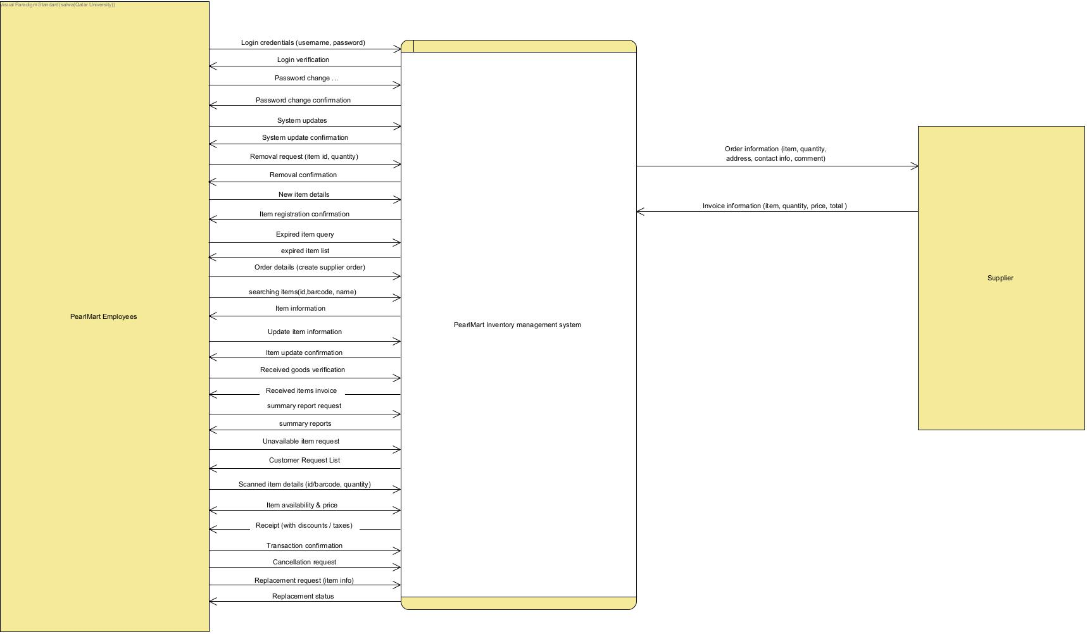
- Data Flow diagram Level 1:
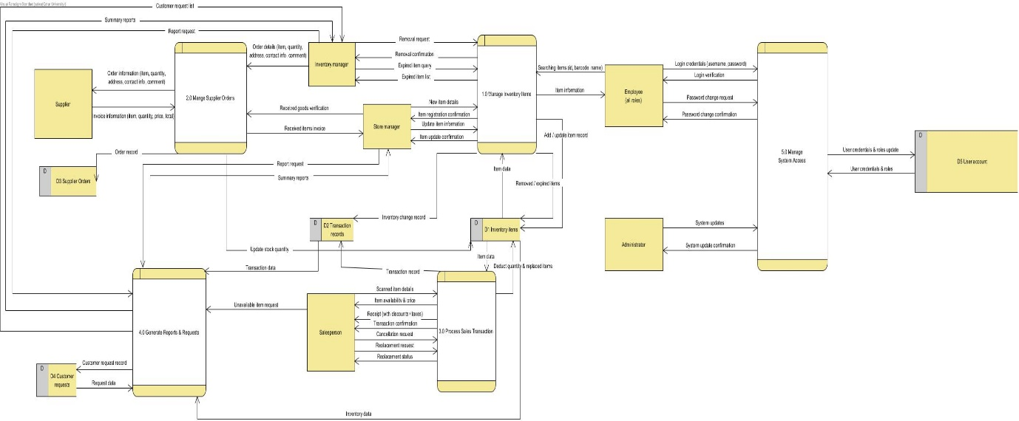

- Data Flow diagram Level 2:
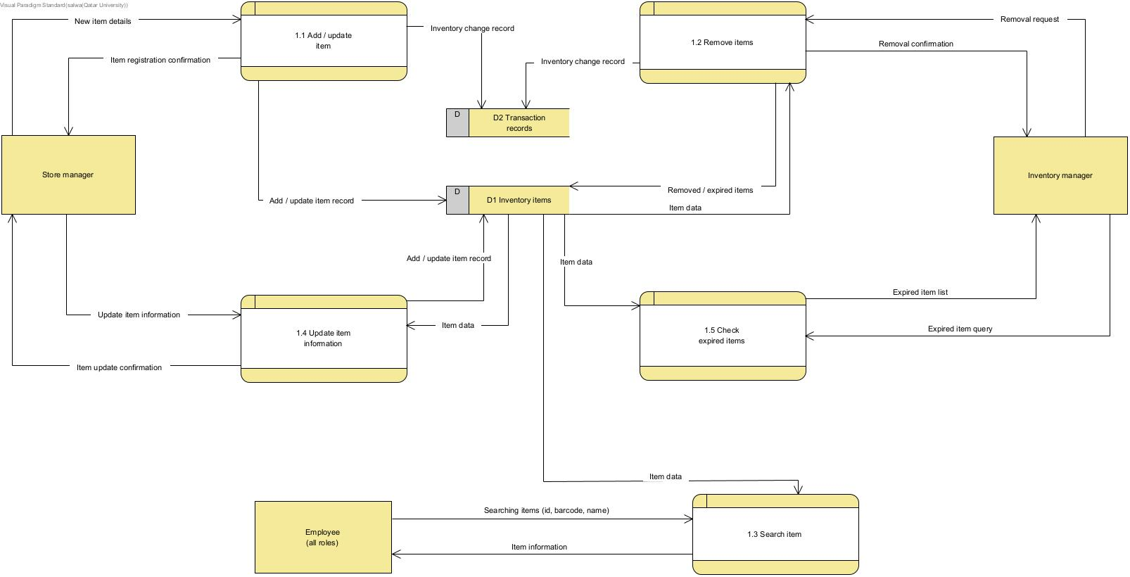
- What the DFD shows how the data (information) moves through the PearlMart inventory system. The data flow is shown through the five processes, (1.0 Manage Inventory Items, 2.0 Manage Supplier Orders, 3.0 Process Sales Transactions, 4.0 Generate Reports & Requests, 5.0 Manage System Access) and how they exchange with the five data stores (D1 Inventory System, D2 Transaction Records, D3 Supplier Orders, D4 Customer Requests, D5 User Accounts). It shows how D1 receives goods by (2.0), and addition and removal of goods with (1.0). And it also reveals how D2 provides reports. As well as, showing how no data enters and leaves without being accounted for in the DFD diagram.
- Use Case diagram:
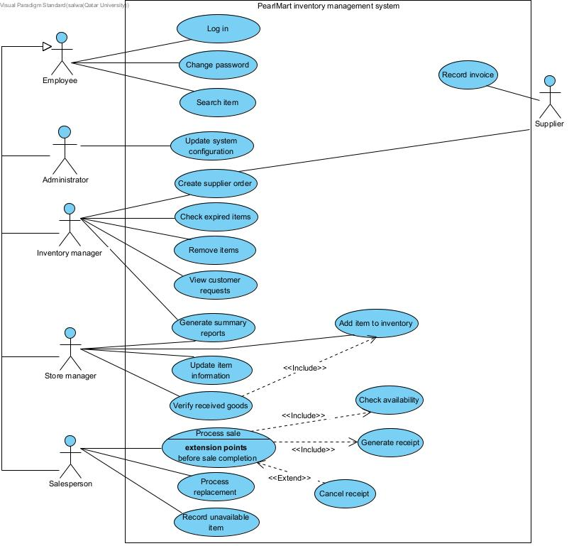

- What the use case diagram shows is who interacts with the system and why. All employees (Administrator, Inventory manager, Store manager, Salesperson) inherit the login and password change ability from Employee, and how each has their own responsibilities that were assigned to them. For example, the administrator updates the system, the Inventory manager checks all expired items and creates supplier’s orders, the Store manager adds items and verifies received goods, the Salesperson processes the sales and any requirements. In addition, it reveals the included use cases (Checking availability, generating receipts), as well as the extended use case (Cancel receipt) that works in optionally. The supplier, that is on the other end, is only involved in ordering and invoicing.

- Strength. Limitations, best use to each diagram:

 | DFD | Use case diagram
Strengths | Shows data flow, the shared data stores, the ability to trace actions throughout the levels. | Shows all roles, responsibilities, scope, as well highlighting the mandatory activities.
Limitations | Does not show who is authorized to which responsibilities, and no clear order of steps | Does not show where that data is saved after processes, no flow of information
Best suited for | Designers and analysts | Clients and end users (e.g. Ms. Sara)

- Complementary use:

Each diagram exposes the limitations of the other. The DFD reveals the missing data flow that the use case fails to show, e.g. the removed items not being updated to D2, and how customer requests are never written into D4. The combination of all employees in (Level 0) blurs each type of employee’s responsibilities and authorized access. The DFD diagram never reveals the process of validations that are required in the system, and the use cases specifications are the ones that reveal them, as well as showing who is responsible and authorized to do such actions.

- Which is better suited to a specific question:

if the question is “where is the inventory quantities are updated? “The DFD diagram is more suited Since each data flow is clearly visible like the flow that comes to and from a process/data store, this satisfies the requirements of this scenario which are the consistent data flow from / to either location. The use case diagram lists actions, such as Remove items, verify received goods and process sale, so if the question is “which role is authorized to remove expired goods?” this question is best answered by the use case diagram, which as mentioned before shows which role is related / responsible to each action.

- Challenges of Sprint 1:
- Use of GitHub as a main tool to track progress was unfamiliar to students, therefore some time was needed for them to get better at using it.
For example, setting up branches, linking issues to pull requests.
- Getting familiar with visual paradigm took some time to master, as well as only one person being able to edit on the project at a time.
- Transforming the background story into different types of diagrams.
- Improvements to be applied to Sprint 2:
- Daily updates of the board rather than every couple of days.
- Reviewing the background story again before starting sprint 2.
- Updating the report of sprint 2 regularly rather than creating it at the end of the sprint.

